1. Count of the Ropa’s are in sync between latest Source file and Dashboard.

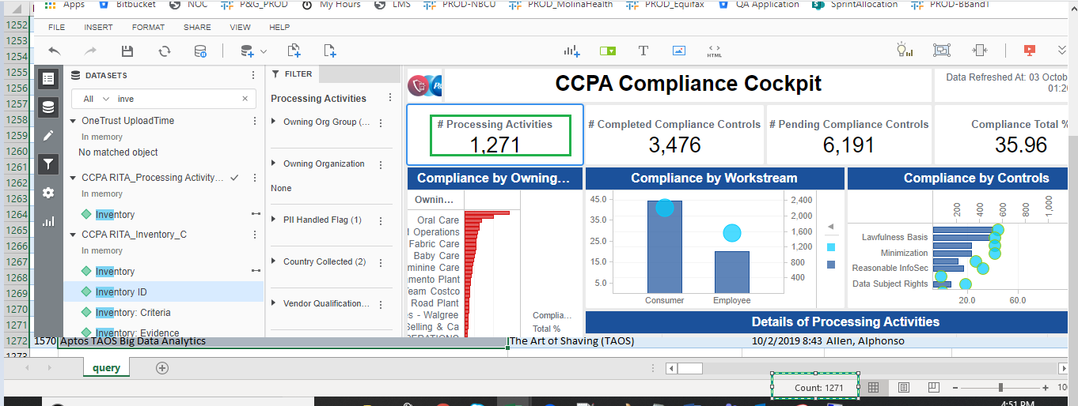

1. 1569 and 1570 Processing activities are now available in the Dashboard.

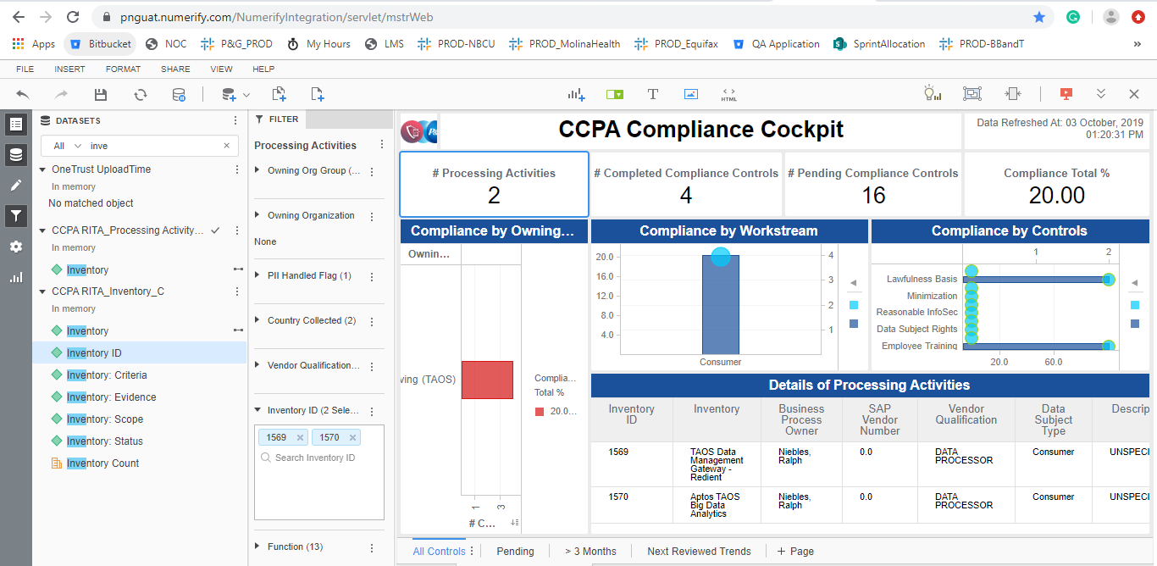

1. With the latest load of the data, 1568 Inventory is not coming in > 3 months tab.

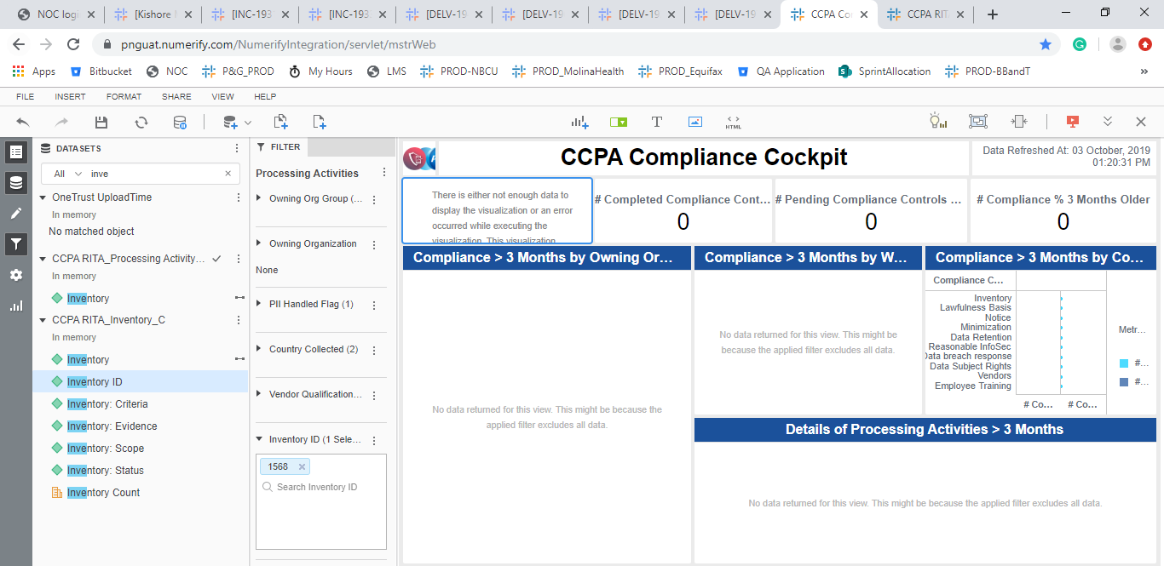

1. > 3month Tab count is working fine.

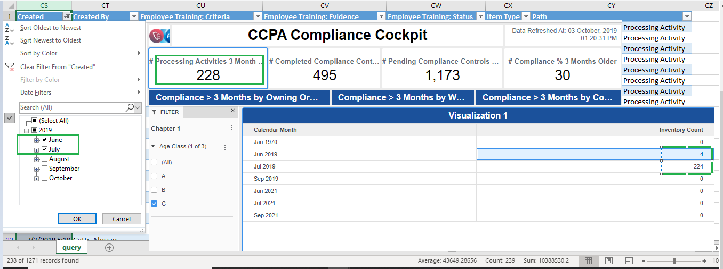

1. Data is same post exporting to excel.

